Jatin Chowdhary [400033011]

Biology Lab 1: Reaction Time To Visual Cues

Lab Instructor: Christine

**Results**

All results listed below are based entirely off of Figure 1. Figure 1 graphs the relationship between color of visual stimuli presented to subject, against reaction time of subject to respond to the color of visual cues. According to figure 1, subject responded to green stimuli with an average reaction time of 0.241 seconds, with a standard deviation of 0.0374. Subject responded to red stimuli with an average reaction time of 0.2485 seconds, and standard deviation of 0.0394. When presented with a biColor1 LED and instructed to only respond to the red stimuli, subject averaged at 0.2865 seconds, with a standard deviation of 0.0540. According to figure 1, subject responded quicker to green stimuli, then red stimuli. Subject averaged 0.0075 seconds faster for green stimuli. Furthermore, the standard deviation for green stimuli is less than standard error for red stimuli; approximately 0.0002 less. When asked to react to only one specific color cue in the biColor1 LED, subject performed slower than subject’s average time for previous color cues. For only red color cues, subject had an average reaction time of 0.241 seconds, and when asked to discern between two different color cues, subject’s reaction time increased by 0.038 seconds to 0.2865 seconds. Subject’s data has remained consistent throughout experiment, with little variability. When presented green cues only, subject’s highest reaction time was 0.37 seconds, and lowest was 0.2 seconds (Table 1). For red cues only, subject’s highest reaction time was 0.38 seconds, and lowest was 0.22 seconds. When presented both colors, subject’s highest reaction time was 0.43 seconds, and lowest was 0.22 seconds. In terms of variability, the subject’s reaction times appears to be relatively consistent for green and red color cues. However, it does increase for the biColor1 LED. The standard deviation for green stimuli was 0.0374, approximately 0.0394 for red stimuli, and 0.0540 when presented both color cues (Refer To Table 1). Subject’s reaction time, and variability, increases when asked to discern between two different stimuli.

Table 1: Displays Raw Data Collected For Subject's Reaction Times To Stimuli

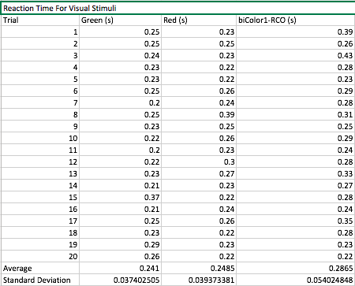

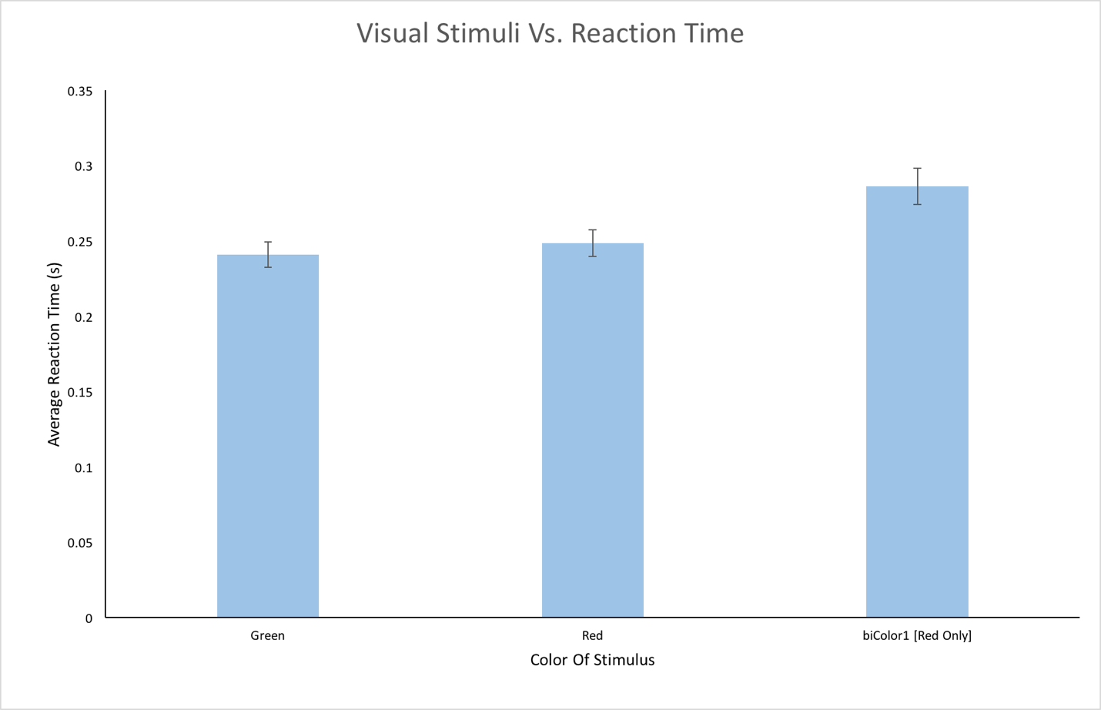

Figure 1: Graph Of Visual Stimuli Versus Reaction Time

